## How to Read and Understand Your Marine Corps Leave and Earnings Statement (LES)

(Published February 2024)

Your pay is your responsibility. It is recommended that you verify your pay and entitlements each month. If it varies significantly and you don't understand why, or if you have questions about your pay and entitlements, please visit your Installation Personnel Administration Center (IPAC) to obtain a better understanding and clarification.

This guide is designed to help you understand your LES. Your LES contains a comprehensive list of pay related items such as your entitlements, deductions, allotments (not applicable to the Reserve Component), leave, Federal & State tax withholdings, Thrift Savings Plan (TSP) deductions and contributions, and your retirement option.

The last 36 months of LESs are accessible via the myPay site.

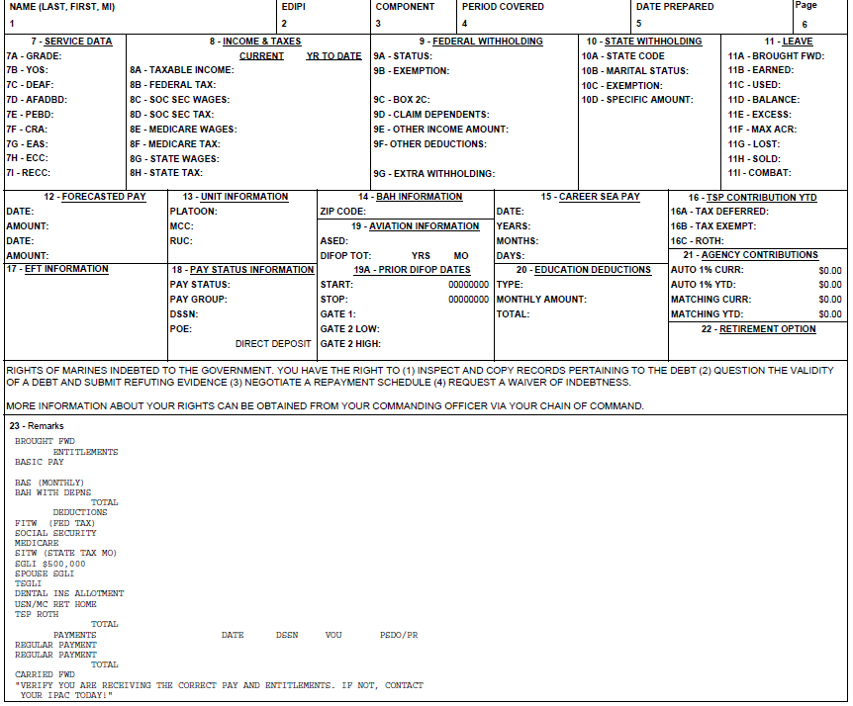

**Block 1 - NAME:** Self-explanatory.

**Block 2** - **EDIPI**: The Electronic Data Interchange Personal Identifier is a number assigned to a record in the United States Department of Defense's Defense Enrollment and Eligibility Reporting System (DEERS) database.

**Block 3 - COMPONENT:** Active or Reserve.

**Block 4 - PERIOD COVERED:** The period covered by the LES. Normally it will be one calendar month.

**Block 5 - DATE PREPARED:** Self-explanatory.

**Block 6 - PAGE:** Self-explanatory.

## Block 7 - SERVICE DATA

**7A - GRADE**: Your pay level (E5, O4, O9)

**7B - YOS**: Years of creditable service for pay

**7C - DEAF**: Date Entered Armed Forces

**7D - AFADBD**: Armed Forces Active-Duty Base Date

**7E - CRA**: Clothing Replacement Allowance Date (Active Only)

**7F - EBD**: Pay Entry Base Date

**7G - EAS**: End of Active Service Date

**7H - ECC**: End of Current Contract Date

**7I - RECC**: Reserve End of Current Contract Date (Reserve Only)

# BLOCK 8 - INCOME & TAXES

**8A - TAXABLE INCOME:** Current month and Year-To Date wages that are subject to Federal Income Tax Withholding (FITW).  
**8B - FEDERAL TAX:** Current month and Year-To-Date Federal Income Tax Withheld (FITW).  
**8C - SOC SEC WAGES:** Current month and Year-To-Date wages subject to Social Security withholding.  
**8D - SOC SEC TAX:** Current month and Year-To-Date Social Security taxes withheld.

**8E - MEDICARE WAGES:** Current month and Year-To-Date wages subject to Medicare withholding.  
**8F - MEDICARE TAX:** Current month and Year-To-Date Medicare taxes withheld.  
**8G - STATE WAGES:** Current month and Year-To-Date wages subject to State Income Tax Withholding (SITW).  
**8H - STATE TAX:** Current month and Year-To-Date State Income Tax Withheld (SITW).

# BLOCK 9 - FEDERAL ITHHOLDING (For details on how to properly select your federal withholdings you’re encouraged to first visit [https://www.irs.gov/pub/irs-](https://www.irs.gov/pub/irs-pdf/fw4.pdf) [pdf/fw4.pdf](https://www.irs.gov/pub/irs-pdf/fw4.pdf))

**9A - STATUS:** Desired filing status.

**Single or Married and filing separately**.|  
**Married filing jointly or a Qualifying surviving spouse**.

**Head of household** (Select only if you’re unmarried and pay more than half the costs of keeping up a home for yourself and a qualifying individual.)

**9B - EXEMPTION:** The numeric quantity of exemptions claimed. Not applicable for the new federal W-4 withholding plan. (The old W-4 version is still valid if you have not made federal withholding changes since 2020)  
**9C - BOX 2C:** Multiple Jobs or Spouse Works. Only select this once you’ve determined it is needed.  
**9D - CLAIM DEPENDENTS:** Credit amount for qualifying children and other dependents. Only select this once you’ve determined it is needed.  
**9E - OTHER INCOME AMOUNT:** Other income (not from jobs) that you want tax withheld for. Only enter an amount once you’ve determined it is needed.  
**9F - OTHER DEDUCTIONS:** Deductions other than the standard deduction that you expect to claim. Used to reduce your withholding. Only enter an amount once you’ve determined it is needed.  
**9G - EXTRA WITHHOLDING:** This is an additional deducted and will be added to the normal withholdings. For the Active Component, this is a dollar amount deducted from each pay period (monthly) and for the Reserve Component, it is a percentage deducted from each payment.

**Note:** If you’re under the old W-4 withholdings, and make changes, your federal withholdings will be computed with the new the tax rates, which may result in lower federal deductions.

# BLOCK 10 - STATE WITHHOLDING

**10A - STATE CODE:** Your state of legal residence.  
**10B - MARITAL STATUS:** Single, Married, or Married - withholding at the Single Rate.  
**10C - EXEMPTION:** The numeric quantity of exemptions claimed.  
**10D - SPECIFIC AMOUNT:** If selected, this will override the normal computed state withholding and will be the only deduction. For the Active Component, this is a dollar amount deducted from each pay period (monthly) and for the Reserve Component, it is a percentage deducted from each payment.

# BLOCK 11 – LEAVE (Active Component Only)

**11A - BROUGHT FWD:** Leave balance from your previous month’s LES.  
**11B - EARNED:** Leave earned during the month. 2.5 days for a full month.  
**11C - USED:** Chargeable leave reported during the month, regardless of the period the leave was reported for.  
**11D - BALANCE:** Leave balance at the end of the month.  
**11E - EXCESS:** Number of leave days taken that exceed the leave days that will be earned for the current enlistment.  
**11F - MAX ACR:** Maximum number of leave days that can be earned during the remainder of the current enlistment.  
**11G - LOST:** Number of leave days lost during the current Fiscal Year.  
**11H - SOLD:** Total number of leave days sold that are characterized as career (60 max).  
**11I - COMBAT:** Balance of combat leave.

# BLOCK 12- FORCASTED PAY (Your forecasted pay amounts and dates. These amounts may change.)

# BLOCK 13 - UNIT INFORMATION

Platoon, Monitored Command Code, and Reporting Unit Code.

# BLOCK 14 - BAH INFORMATION

**ZIP CODE**: Used to determine your Basic Allowance for Housing Amount. Based on your duty station ZIP code, Tour Status (Restricted/Unrestricted) and dependent status and location.

# BLOCK 15 - CAREER SEA PAY

Career Sea Pay totals and your last day of Career Sea Pay.

# BLOCK 16 - THRIFT SAVINGS PLAN (TSP) CONTRIBUTIONS YTD

**16A - TAX DEFERRED:** Year-to-date TSP contributions that are tax deferred. These contributions lower your taxable income.  
**16B - TAX EXEMPT:** TSP contributions that are tax exempt. These contributions are earned from Combat Zone wages.  
**16C - ROTH:** Year-to-date Roth TSP contributions. These contributions are after tax contributions.

## Block 17 - EFT INFORMATION

Name and address of the financial institution where your payments will be electronically deposited.

## Block 18 - PAY STATUS INFORMATION

The pay status, pay group, and Disbursing Station Symbol Number assigned to your pay record.

## Block 19 – AVIATION INFORMATION

**ASED:** Aviation Service Entry Date, the date originally assigned to flight training.  
**DIFOP TOT:** Total career amount of Duties Involving Flying – Operational earned.  
**YRS:** Years in a DIFOP status.   
**MO:** Months in a DIFOP status.

**19A - PRIOR DIFOP DATES**

**START:** Prior DIFOP begin date.

**STOP:** Prior DIFOP end date.  
**GATE 1:** The year Gate 1 was passed for DIFOP. Passing this gate within 12 years from the ASED, allows AVIP to continue regardless of DIFOP/DIFDEN Status through 18 years.  
**GATE 2 LOW:** The year Gate 2 low was passed for DIFOP. Passing this gate within 18 years from the ASED, allows AVIP to continue regardless of DIFOP/DIFDEN Status through 22 years.  
**GATE 2 HIGH:** The year Gate 2 high was passed for DIFOP. Passing this gate within 18 years from the ASED, allows AVIP to continue regardless of DIFOP/DIFDEN Status through 25 years.

**NOTE:** For Aviators, if the Flight Status reflects as DIFDEN-2, AVIP only continues for 48 months while in a DIFDEN-2 status. Review your DIFDEN-2 Lapse Date on your AVIP screen.

## Block 20 - EDUCATION DEDUCTIONS (Monthly and total amounts deducted for Montgomery GI Bill participants.)

**Block 21 - AGENCY CONTRIBUTIONS** (Blended Retirement Participants Only)

**AUTO 1% CURR:** 1% of your Basic Pay earned for the current month and paid by the Marine Corps.  
**AUTO 1% YTD:** Year-to-date automatic TSP 1% contributions.  
**MATCHING CURR:** TSP matching contributions paid by the Marine Corps for the current month.  
**MATCHING YTD:** TSP matching contributions paid by the Marine Corps Year to Date.

## Block 22 - RETIREMENT OPTION (Your selected retirement option Blended Retirement, High Three (36 Months), or CSB Redux.)

# DRILL INFORMATION (When applicable) REGULAR MONTH: Number of regular drills reported during the current month, regardless of when performed. REGULAR ANNIVERSARY: Number of regular drills reported for the current anniversary year. REGULAR FY: Regular drills reported during the current fiscal year. ADD MONTH: Number of drills reported, other than regular drills, during the current month. ADD ANNIVERSARY: Number of drills reported, other than regular drills, during the current anniversary year. ADD FY: Number of drills reported, other than regular drills , during the current fiscal year.

# RETIREMENT POINTS

**DRILLS:** Number of drills recorded during the current month, regardless of when performed.  
**OTHER:** Number of non-regular drills recorded during the current month (i.e., Funeral Duty Honors), regardless of when performed.  
**ACTIVE DUTY:** Number of Active-Duty days recorded during the current month, regardless of when performed.  
**ANNIVERSARY:** Retirement points earned for the current anniversary year.  
**TOTAL:** Retirement points earned in a career.  
**SAT YEARS:** Satisfactory years earned towards a Reserve Retirement.

## Block 23 – REMARKS (This area contains your brought forward balance from the previous month, entitlements, deductions, allotments, payments, and various other important pay related messages related to starts, stops, and changes to your pay items.)